**Parkland Primary School Curriculum Newsletter**

Year 3 Term: Autumn 2

[This Photo](https://en.wikipedia.org/wiki/Ultraviolet_astronomy) by Unknown Author is licensed under [CC BY-SA](https://creativecommons.org/licenses/by-sa/3.0/)

**Maths**

In maths, we are continuing to learn about addition and subtraction.

* Addition and subtraction of up to 3-digit numbers with and without renaming.

Start to learn about:

* Multiplication and division using a range of strategies supported by our times tables knowledge.

Our times tables focus is 2’s, 5’s, 10’s and 4’s.

**Reading**

In guided reading, we are learning to use our Reading Dogs – Rex Retriever, Vocabulary Victor, Summarising Sheba and Inference Iggy, to help us to answer comprehension questions on a text.

Our Class text this term is Journey to the Centre of the Earth by Jules Verne.

**Autumn 2**

**Topic: Tremors**

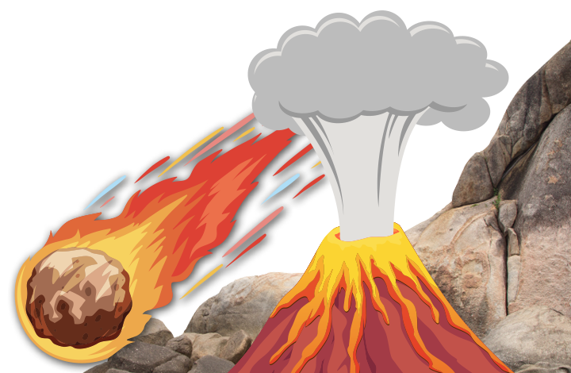

**English**

In English, this term we are learning how to write a diary entry, an information leaflet and some instructions.

The key knowledge and skills, we will be learning are:

* Using imperative verbs.
* Using the past tense
* Writing in the 1st person
* Writing in paragraphs
* Creating a glossary.

**Wider Curriculum Learning Journeys**

In Geography, we are learning the layers of the Earth, volcanoes, earthquakes, mountains and about the Earth’s tectonic plates.

In science we will be looking at plants.

In RE, we are looking at people of God

**PSHE and Wellbeing**

Our PSHE topic this term is called Keeping Safe.

We will be learning about protective behaviours (understanding unsafe feelings, body awareness and networks), to recognise dangers and risks and avoid negative influences.

**Noticeboard**

Term: Autumn 2

**Water Bottle**

Please ensure your child has a **re-useable** water bottle with them in school to keep them healthy and hydrated.

**PE Days**

**Please remember to send your child to school in school PE kit on their PE days.**

3DR – Tuesday and Wednesday

3RD – Monday and Wednesday

3TM – Wednesday and Friday

**Home Learning**

This will be shared via Class Dojo.

Please read daily with your child and encourage them to practise the weekly spellings and times tables.

**Reminders**

**Key Dates this Term**

|  |  |
| --- | --- |
| Date | Event |
| Tuesday 1st November 2022 | **EYFS Disco:** 3.15pm – 4.15pm  **Y3/4 Disco**: 4.30pm – 5.30pm |
| Wednesday 2nd November 2022 | **Y1/2 Disco:** 3.15pm -4.15pm  **Y5/6 Disco:** 4.30pm – 5.30pm |
| Friday 11th November 2022 | Remembrance Day |
| Tuesday 15th November 2022 | PTA Harvest Meal 5pm – 6.30pm |
| Friday 18th November 2022 | Children In Need/Anti-Bullying Week |
| Friday 18th November 2022 | Flu Vaccination (Foundation to Year 6) |
| Monday 21st November 2022 | **SCHOOL CLOSED – PD Day** |
| Thursday 1st December 2022 | Christmas Decoration Day  **Pre-School:** 9.00am – 10.15am  **EYFS & Y1/2:** 9.00am – 10.15am |
| Friday 2nd December 2022 | Christmas Decoration Day  **Y3/4/5/6:** 9.00am – 10.15am |
| Thursday 15th December 2022 | Christmas Dinner Day |
| Monday 19th December 2022 | **SCHOOL CLOSED FOR CHRISTMAS BREAK** |