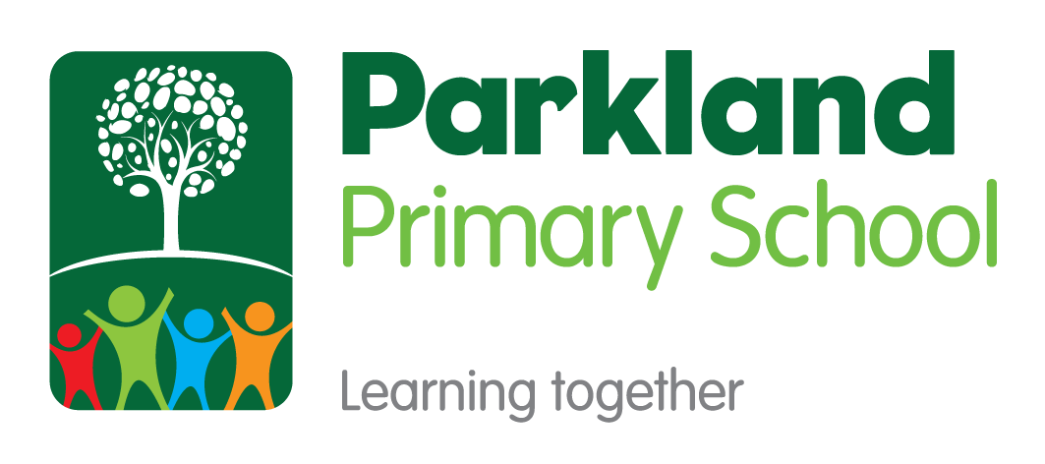

Religious Education
Subject Policy

Subject Leader(s): Demi Marvin
Last Reviewed: March 2022

Rationale
This policy outlines the intent, implementation and intended impact for the teaching, leadership, and assessment of Religious Education at Parkland Primary School. The school’s policy for Religious Education follows the 2014 National Curriculum Framework, Leicestershire Agreed RE Syllabus 2021-2026, and the Early Years Foundation Stage Framework.

Our Mission
At Parkland Primary School, we believe that every child in our school community should have Limitless Learning opportunities. We all have the ability to succeed and our school works hard to ensure that our pupils can Discover their Potential.
Our Values: Grow, Believe, Achieve, Succeed

Intent
At Parkland Primary School we have worked together to create a shared language for learning (Appendix 1). Underpinning this and all curriculum design is our whole school definition of learning:
‘Learning is the process of building on and strengthening the connections in your brain.’

Our intent is for a high-quality Religious Education curriculum which is coherent, progressive, pedagogically and philosophically sound, and promotes the cognitive, spiritual, moral, social and cultural development of all learners.
Aims of Religious Education knowledge-led curriculum:
- The principal aim of religious education is to explore what people believe and what difference this makes to how they live, so that pupils can gain the knowledge, understanding and skills needed to handle questions raised by religion and belief, reflecting on their own ideas and ways of living.
The curriculum for RE aims to ensure that all pupils:
- Make sense of a range of religious and non-religious beliefs, so that they can:
• Identify, describe, explain and analyse beliefs and concepts in the context of living religions, using appropriate vocabulary.
• Explain how and why these beliefs are understood in different ways, by individuals and within communities.
• Recognise how and why sources of authority (e.g., texts, teachings, traditions, leaders) are used, expressed and interpreted in different ways, developing skills of interpretation.

- Understand the impact and significance of religious and non-religious beliefs, so they can:
• Examine and explain how and why people express their beliefs in diverse ways.
• Recognise and account for ways in which people put their beliefs into action in diverse ways, in their everyday lives, within their communities and in the wider world.
• Appreciate and appraise the significance of different ways of life and ways of expressing meaning.

- Make connections between religious and non-religious beliefs, concepts, practices and ideas studied, so that they can:
• Evaluate, reflect on and enquire into key concepts and questions studied, responding thoughtfully and creatively, giving good reasons for their responses.
• Challenge the ideas studied, and allow the ideas studied to challenge their own thinking, articulating beliefs, values and commitments clearly in response.
• Discern possible connections between the ideas studied and their own ways of understanding the world, expressing their critical responses and personal reflections with increasing clarity and understanding.
(Leicestershire Agreed Syllabus, 2021-2026)

Throughout pupils’ time at Parkland Primary School, teachers should consider how their teaching contributes towards the principal aim of RE in the local area, and how they help pupils to achieve the further aims for a knowledge led RE curriculum.

At Parkland Primary School, teachers work collaboratively using subject progression maps and knowledge mapping to coherently plan and sequence learning journeys designed to allow our pupils to gain cumulatively sufficient knowledge to ensure they are ready for the next stage of their education.

Curriculum Drivers
At Parkland Primary School, through the delivery of a high-quality knowledge led Religious Education curriculum we aspire for our pupils to be…

Implementation
How Religious Education is planned and taught:
Teachers work collaboratively to plan Religious Education using the learning journey planning format (Appendix 2). Religious Education is planned using progression maps and knowledge mapping to ensure teaching is designed to help learners to remember, in the long term, the content they have been taught and to integrate new knowledge into larger concepts.
For the wider curriculum we block learning and re-visit practice over time through a spaced practise approach (Learning Scientists, 2016) as research suggests this will lead to better long-term retention of knowledge. Retrieval practice is a fundamental part of our Religious Education curriculum as it is proven to strengthen memory and make it easier to retrieve the information later (Rosenshine, 2012). Opportunities for retrieval practise occur in two places in the curriculum:
- Weekly review to activate prior learning forms the start of most lessons.

EYFS:
The EYFS framework is structured very differently to the national curriculum as it is organised across seven areas of learning rather than subject areas. The skills taught across EYFS feed into the Religious Education curriculum but are not always taught as subject specific knowledge and skills. The most relevant early years outcomes for RE are taken from the areas of learning within “Understanding the World”.

The knowledge and skills needed to achieve these outcomes are taught mostly through children playing and exploring during continuous provision times in the day. Teachers deliberately plan enhanced activities which give opportunity for children to learn through their own discovery. Some elements of Understanding the World are taught through RE lessons in which the children learn about People and Communities and important events in the world such as religious festivals.

KS1/ KS2:
This agreed syllabus requires that all pupils learn from Christianity in each key stage. In addition, pupils will learn from the principal religions represented in the UK, in line with the law. These are Islam, Hinduism, and Judaism. Furthermore, children from families where non-religious worldviews are held are represented in almost all our classrooms. These worldviews, including for example Humanism, will also be the focus for study.
Phase and subject leaders are responsible for ensuring that the taught curriculum in each phase mirrors the intended progression of knowledge and skills mapped out for each year group in the progression document. Therefore, ensuring previous content supports subsequent learning and pupils are equipped with the knowledge necessary for the next stage in their education and that the full content of National Curriculum is taught before children leave Parkland Primary School.
Pupils in Key Stage 1 and Key Stage 2 have an RE lesson once a week.
Effective teaching of Religious Education:
Parkland Primary School prides itself on being a research informed school. Following staff training on Rosenshine’s Principles in Action (Sherrington and Caviglioli, 2019) schoolteachers are expected to actively present material and structure lessons using the ten principles of instruction below. These principles not only facilitate the memorising of information but allow pupils to understand it as an integrated whole, and to recognise the relationships between the parts. This does not mean that every lesson needs to follow the exact structure or sequence, and this is not intended to be used as checklist for each lesson; these elements can occur at different points in a lesson, or over a sequence of lessons, and can be integrated in different ways and at different times.
Principles of Instruction:
- Daily Review – lessons begin with a short review of previous learning to re-activate recently acquired knowledge.
- Present new material using small steps – recognise the limitations of the working memory by breaking down concepts and procedures into small steps.
- Ask questions – teachers need to ask large numbers of questions to check for understanding
- Provide models – a central feature of giving good explanations. These may include concrete models to aid abstract concepts, worked narrative examples modelling a process
- Guide student practice – give time to guide student practice supported by modelling, corrective feedback and re-teaching where gaps remain.
- Check for student understanding – teachers use their questioning to ascertain from as many children as possible what they have understood? A range of questioning strategies below can be used to do this (see below).
- Obtain a high success rate – teachers need to engineer a high success rate (around 80%) where children are reinforcing error-free, secure learning, improving fluency and confidence providing a platform for independent practice. However, it is still important pupils are challenged here (a success rates a 90%+ is too high).
- Provide scaffolds for difficult tasks – temporary aids may be required to support children in developing a level of independence but are withdrawn at the right point so that pupils don’t become reliant upon them.
- Independent Practice – here teachers need to construct learning so that students can do challenging things by themselves without help. It is important that the material that students practise is the same as during guided practise for appropriate levels of success to be secured
- Weekly and Monthly Review – to ensure that previously learned material is not forgotten and break the forgetting curve. A variety of retrieval techniques can be used to do this.
Questioning Strategies used at Parkland Primary School:
- How do you know? Justify Why?
- What’s the same? What’s different?
- Mathematical Superhero’s: Captain conjecture, Ace organiser, Canine the Convincer, The Classifier, The Specialiser, The Visualiser and Excellent Expressor
- Think – Pair – Share
- Cold call (no hands up)
- No opt out (bounce back if a child can’t answer initially)
- Probing questions (staying with a child to probe deeper to check understanding)
- Say it again better (ask children to rephrase answers a second time to build a deeper, high-quality answer)
- Agree, Disagree, add your own… (to structure class discussion around a question)
- Whole class response: choral, whiteboard, ABCD, thumbs up + down for true or false
Inclusion and Equal Opportunities (challenge for all):
In line with our mission statement, we believe every child will have equal opportunity to achieve their full potential and access an ambitious and coherent curriculum that leads to deep learning and an understanding of a sustainable world. Regardless of race, gender, cultural background, ability or Special Educational Needs or Disability.
If a child has a special educational need or disability, we will do our very best to ensure we meet that child’s individual needs when accessing the Religious Education curriculum. We comply with the requirements set out in the SEND Code of Practice. If a teacher has concerns about the progress of a child, then they will liaise with the in school SENDCO to arrange appropriate assessment of need and set up personal provision through initially writing a Personalised Provision Plan. In some cases, where the demands of the curriculum may be too much, this may involve the use of PIVATS targets to track small step progress for this child or differentiation within the classroom environment to meet the needs of that child.
Impact
Assessing Progress
Assessment:
Pupils’ progress will be assessed using regular formative assessment in lessons through strategies such as questioning, regular retrieval practice, quizzing, independent learning tasks and assessment of work and feedback. Learning in RE will be evidenced each week on tapestry for EYFS and OneNote/big books for key stage 1 and 2.
Each Unit of Learning will be assessed on a unit proforma which will be updated at the end of each lesson. Teachers will use this assessment to provide further feedback or re-teach concepts where necessary to close gaps and ensure pupils have mastered the curriculum content at that point.
Assessing long-term learning:
Skills will be sequentially re-visited and built upon due to the coherently planned and sequenced progression mapping across the school.
Tracking Pupil Progress:
Teachers of Religious Education use the Unit Assessments for each unit of the Leicestershire Agreed RE Syllabus. These are completed for a whole class to assess which pupils are emerging, expected and exceeding in the expectations from the syllabus. (Appendix 3)
Individual progress is reported to parents through two termly Parents’ Evenings and an end of year report.

References:
Leicestershire County Council (2021-2026) Leicestershire Agreed Syllabus
Rosenshine. B. (2012) Principles of Instruction: Research-Based Strategies That All Teachers Should Know. American Educator, 36 (1) p12-19.
Sherrington, T. and Caviglioli, O. (2019) Rosenshine's Principles in Action.
The Learning Scientists (2016). [Posters and Blogs]. Available at: https://www.learningscientists.org [Accessed 6 Sep. 2019].
Bibliography:
Chistodoulou, D. (2016) Making Good Progress: The future of Assessment for Learning

